Library Management System: Business Requirement Document

# 1. Introduction

The Library Management System (LMS) will automate the process of managing books, users, and transactions like borrowing and returning. It will provide accurate real-time data on book inventory and user activity, improving efficiency and the user experience.

# 2. Problem/Impact/Outcome

The Problem: The current manual system for tracking books and users leads to delays and errors in updating records, such as lost books or overdue fines.

The Impact: Manual management results in errors, inefficiencies, and poor user experience.

The Successful Outcome: A successful LMS will automate tracking, reduce human errors, and improve overall management and user experience.

# 3. Objectives

Automate the management of library inventory (books) and users.

Provide real-time tracking of book availability and user activities.

Simplify book borrowing and returning processes with accurate tracking of due dates and overdue fines.

# 4. Scope

In-Scope:

1. Managing book inventory, user profiles, and transactions.

2. Real-time search feature for available books and reservation options.

Out-of-Scope:

1. Integration with external libraries or advanced analytics tools.

# 5. Assumptions

Library staff and users will be trained to use the system.

The system will run on the institution’s network and be accessible via stable internet connection.

# 6. User Personas

Librarian: Manages book inventory, tracks late returns, and updates records.

Student/Staff: Borrows and returns books, views the catalog, and checks due dates.

# 7. User Stories

As a librarian, I want to manage book inventory efficiently so I can keep accurate records of available and borrowed books.

As a student, I want to search and reserve books online so I can save time during library visits.

As a student, I want to receive notifications about due dates so I don’t incur overdue fines.

In the **Library Management System (LMS)**, librarians will manage book inventory and user profiles to ensure accurate tracking of book availability and borrowing activities. Students will be able to search for books, borrow, return, and reserve them digitally. The system will also send notifications to students about due dates and fines to avoid overdue penalties. Additionally, librarians can generate reports on book circulation and user activity for better decision-making, while system administrators will control role-based access to ensure data security and proper user permissions.

# 8. Detailed Requirements

## 8.1 Functional Requirements

The system must track all book details (ISBN, title, author, etc.) and status (available, borrowed).

The system must allow users to borrow, return, and renew books.

The system must automate overdue fine calculations based on return dates.

Users must be able to search and reserve books.

## 8.2 Non-Functional Requirements

The system must ensure data security for user and book records.

The system should handle at least 100 concurrent users.

The system should have a user-friendly interface suitable for all users.

# 9. Diagrams Overview

## 9.1 Entity-Relationship (ER) Diagram:

The ER diagram will represent entities such as 'Books', 'Users', 'Transactions' and their relationships.

## 9.2 Use Case Diagram:

The use case diagram will illustrate how different users (Librarians, Students) interact with the system.

# 10. Risks

Risk of data loss or downtime affecting user experience.

Unauthorized access to user data leading to privacy breaches.

# 11. Dependencies

Integration with the institution's authentication system for user verification.

Availability of a reliable IT infrastructure.

# 12. Context Diagram

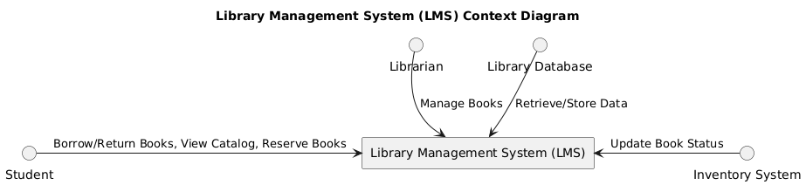

* **Librarians** manage books in the LMS.
* **Students** borrow, return, and reserve books while viewing the catalog.
* The **Inventory System** ensures that book availability is always up to date.
* The **Library Database** stores and retrieves important data for the LMS.

This context diagram provides a high-level view of how different users and systems interact with the LMS, defining the boundaries and key exchanges of information.

# 13. Process Diagram

* **Student** searches for a book through the LMS.
* The **LMS** checks with the **Inventory System** to see if the book is available.
* If the book is available, the student can **borrow** the book.
* The **Inventory System** updates the book's status to "checked out", and the **Library Database** records the transaction.
* When a **return** occurs, the process repeats, with the **Inventory System** updating the book's status to "available", and the transaction is again recorded in the database.
* For the **reservation** process, the LMS updates the reservation information in the **Library Database**.
* **Librarians** manage the books, and the **LMS** keeps both the **Inventory System** and **Library Database** up to date.

# ERD Diagram:

**Entities:**

* **Student**: Represents students using the library.
* **Book**: Represents books in the library.
* **Librarian**: Represents library staff managing the system.
* **Transaction**: Tracks borrowing and returning of books.
* **Reservation**: Tracks book reservations.
* **Inventory**: Tracks the stock of books in the library.

**Relationships:**

* **Student** borrows books (Transaction) and reserves books (Reservation).
* **Book** is part of transactions and reservations.
* **Librarian** manages both books and transactions.
* **Inventory** stores the books and tracks their quantity.

**How to use:**

1. Copy the above code.
2. Paste it into a PlantUML Editor.
3. Click **"Submit"** to generate the **ER Diagram**.

This diagram illustrates the relationships between key entities in the **Library Management System**.

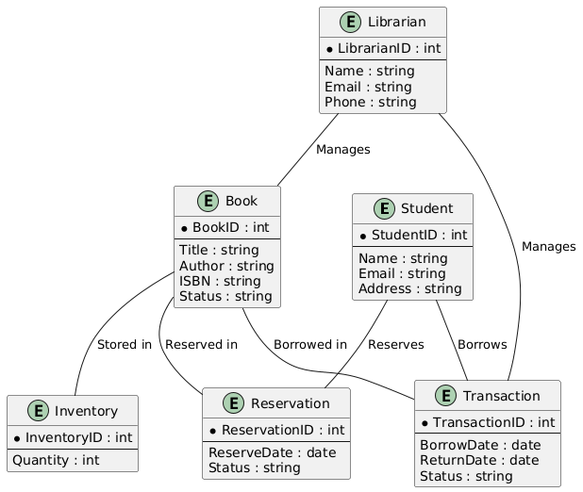

# Wireframe or Mock-up Diagram:

**LMS Dashboard**:

* The main screen contains a **Header** ("Library Management System"), a **Sidebar** with menu options, the **Main Content** area for searching books, and a **Footer** with links (Contact, Help).

**Sidebar**:

* Contains menu options such as "Dashboard," "Manage Books," "Manage Users," "Borrowed Books," and "Reserved Books."

**Main Content**:

* Includes a **Search Bar** and a section for displaying **Book Results**.

# State Diagram

**Available**: The default state when a book is added to the inventory.

**Borrowed**: When a student borrows a book, it moves from the **Available** state to the **Borrowed** state.

**Returned**: After a student returns the book, it enters the **Returned** state.

**Reserved**: A book can also be reserved by a student, moving from **Available** to **Reserved**. Once the reservation is canceled or the book is borrowed, the state changes accordingly.

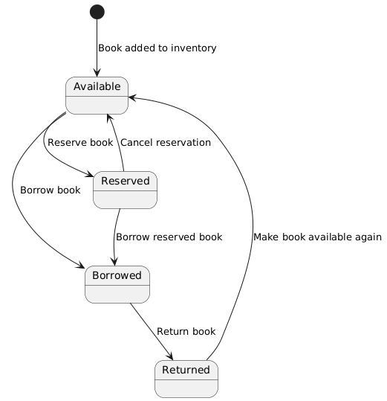

# Activity Diagram

**Student searches for a book**: The activity begins when a student searches for a book in the LMS.

**Check availability**: The system checks if the book is available.

**If available**: If the book is available, the LMS displays the book, processes the borrow request, updates the inventory, and records the transaction.

**If not available**: If the book is not available, the system informs the student, and the student can place a reservation. The reservation is then recorded in the database.

**Send confirmation**: After the process, a confirmation is sent to the student.

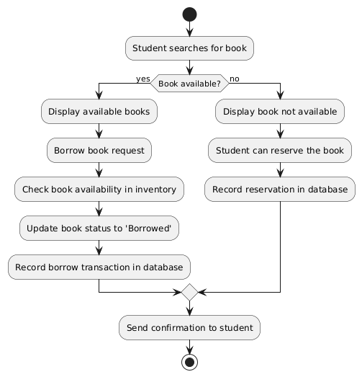

# 12. Conclusion

The Library Management System aims to streamline library operations, improve user satisfaction, and ensure better management of library resources through automation and efficiency.